How to Use Discord

Step 1
Click the link to the server https://discord.gg/DUYfx6s
If you have not already, download the discord app, or you can continue using the web version (I highly recommend getting the app for your computer or your phone).
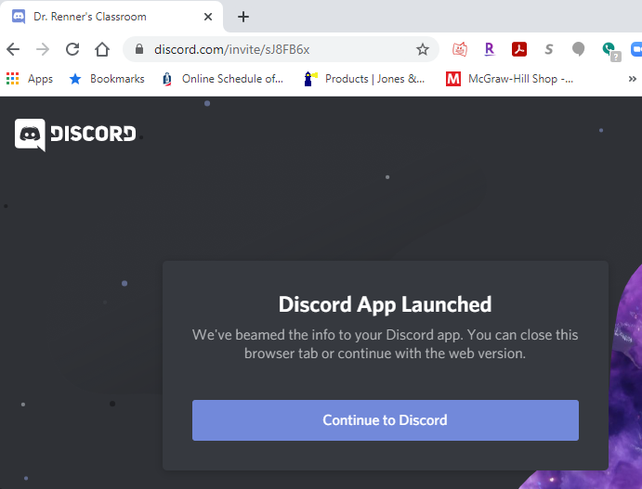

Step 2
Register or Log in (if you already have an account).
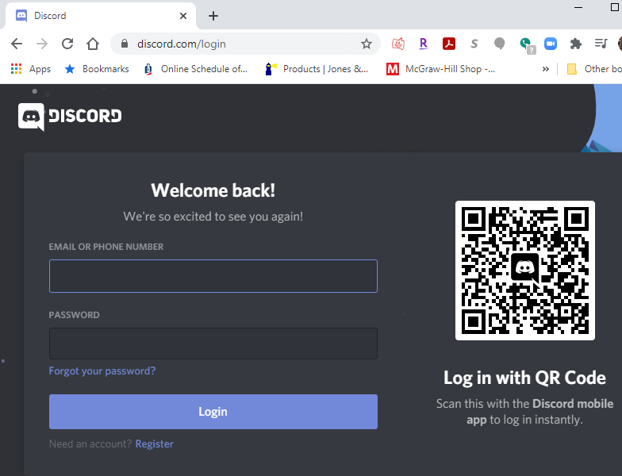
If you have the Discord app on your phone, you can use the QR code to automatically log in.

Step 3
Click the image that shows the golden retriever on the left side. This is the server. When you hover it with your mouse, it should say "CSU #CougarsCare."
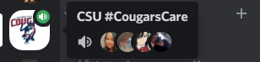

Step 4
Go to "Role Request" and click the emoji that matches which orientation and color you are in. You can also add which residence hall you will be residing in as well (or non-resident for those living off campus).
For example, for those in Color Group Blue on June 8th AM orientation, you should react with the color Blue by clicking on the blue square emoji at the bottom of the message. Once you have, you should be able to see the Voice channels for the Main Lobby and your color group as well as the General chat and your Color group’s chat.
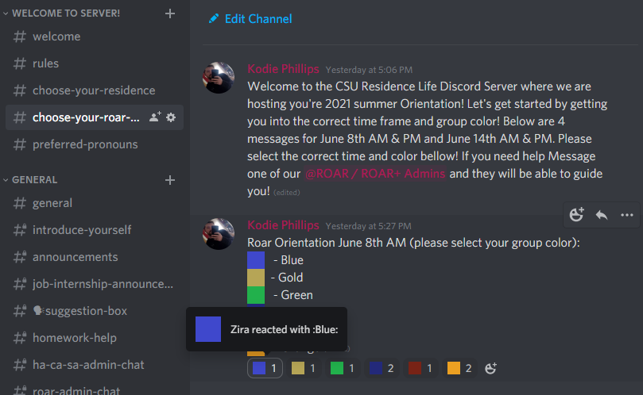
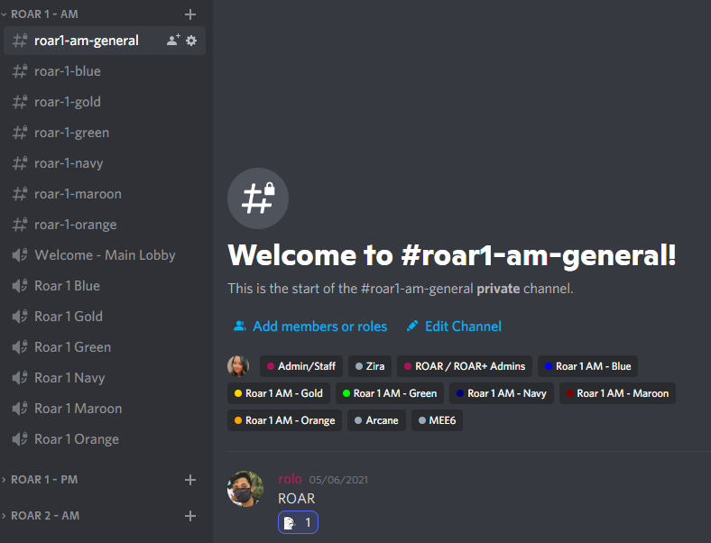
When choosing your residence hall, you react the same way. For those who live in Columbus Hall, you react with (or click) the pear emoji below the message in #choose-your-residence! Afterwards, you will be able to see the rest of the server, such as the Residence Hall specific chats & voice channels
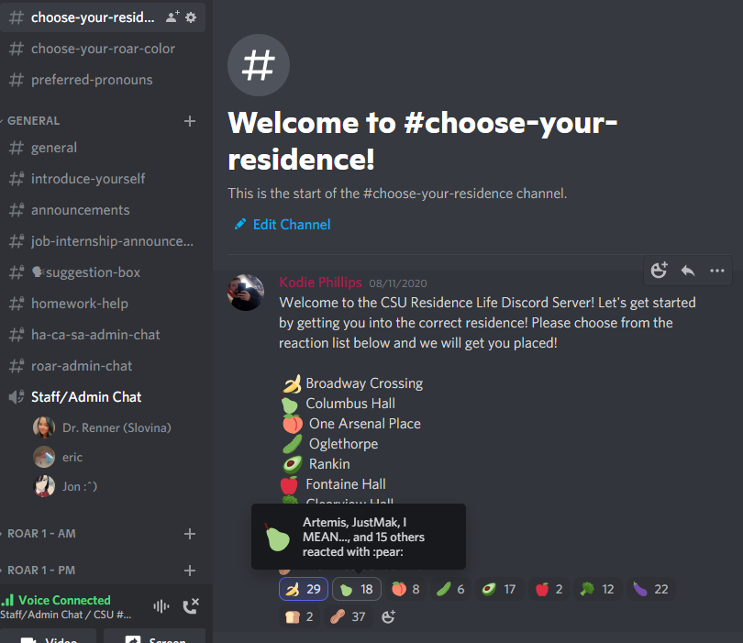
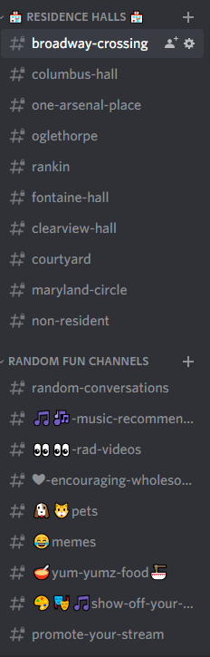

To Join the Voice Chat Remotely and Use the Chatrooms
To use the chatroom, click the appropriate ROAR channel, and you can type to myself or your fellow orientation group mates by text.
To join the voice channel, click the appropriate voice chat. You should see your name pop up under the voice chat.
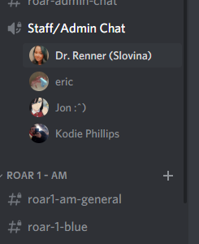
To be able to view my screen, click my name where it says "LIVE" and then click "Watch Stream."
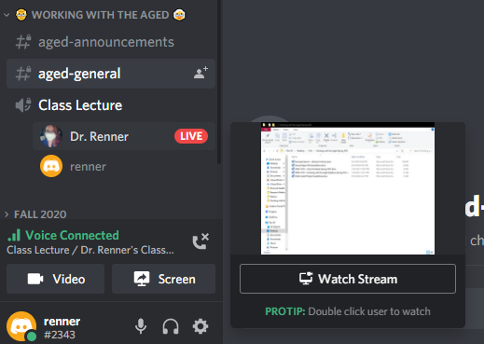
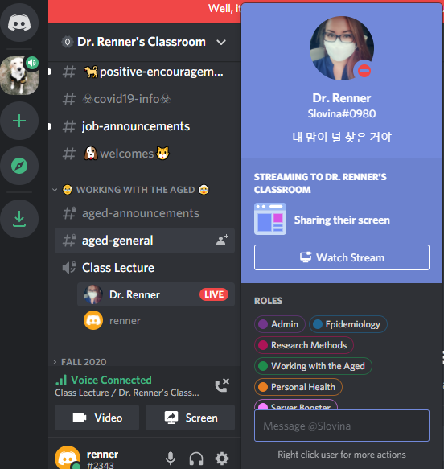
From that point, you should be able to see whatever I am sharing on my screen (or whatever someone else is sharing).
You can also watch multiple screens at the same time by clicking the button with an Eye+ next to the other person you want to view. Or swap between streams by clicking “Watch Stream.”
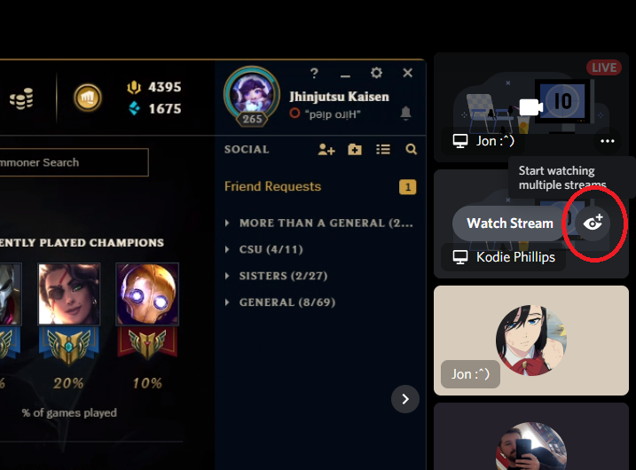

Messing with My Video, Audio, or Mic
To mute your mic, click the mic button.
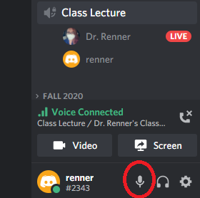
You should see a red slash appear on top of the mic.
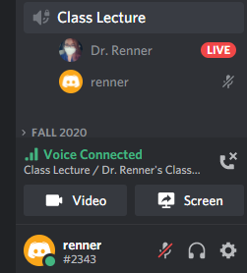
If you click the headset button, you have deafened yourself. You won't be able to hear or say anything.
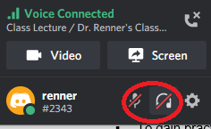
The cogwheel to the right of the headset button is the user settings button. To change your sound settings, click the cogwheel. Then go to Voice & Video.
When you change your "input device," this is changing your mic. You can also test your mic by clicking "Let's Check" below. When you change your "output device," this is changing where you will hear sound from discord.
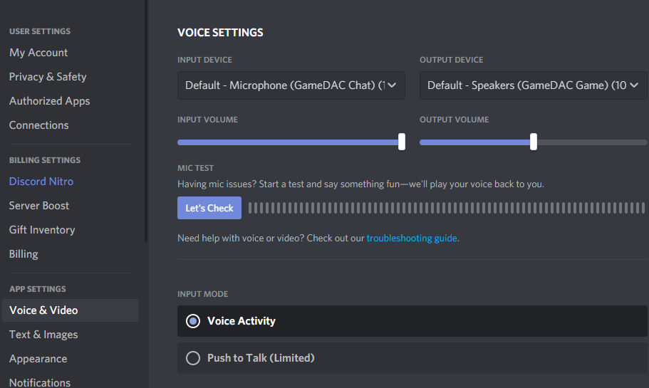
You can also change how your mic picks up sound by going to input mode. Choosing "Voice Activity" means that your mic will pick up when you speak (and sometimes background noise as well). If you choose "Push to Talk," you will need to select and use a keybind to let your mic pick up your voice (think of it as an old school walkie-talkie).

How Do I Share My Screen?
Click the "Screen" button.
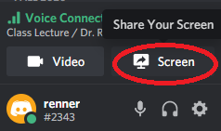
You can then choose whether to share your whole screen, just 1 application window, or a google chrome tab. If you need to also share audio, make sure to check the box for "Share audio." Then click "Share."
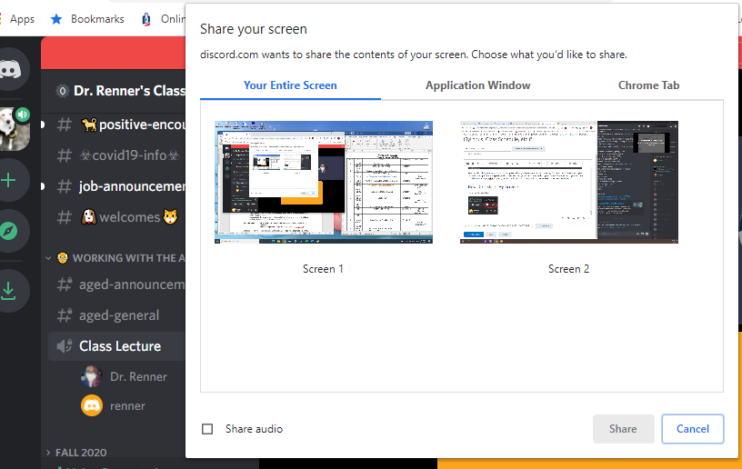
We can even have multiple people share screens, and you can view multiple screens by pressing the "Start Watching Multiple Streams" eye on the additional screen you want to view.
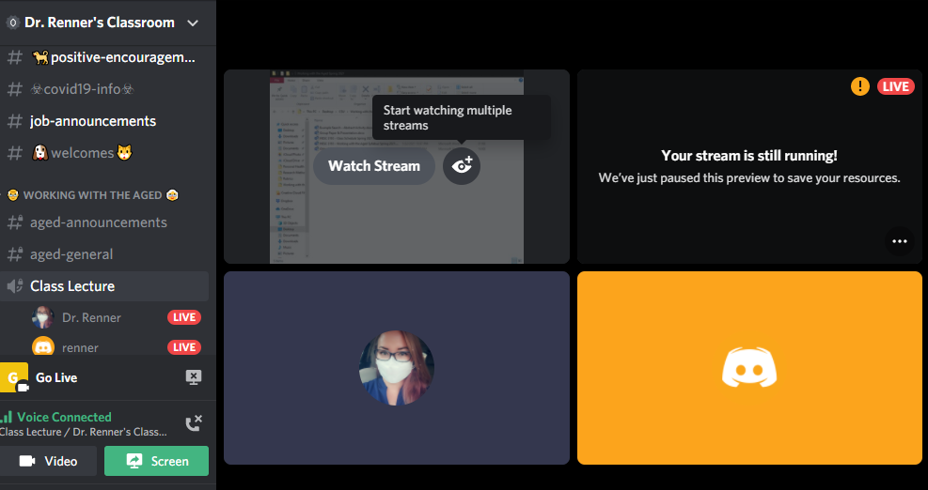
It will then look like this
