Final Report – Music Performance Anxiety Project
Faculty: Stephanie da Silva and Lisa Oberlander
Students: Clarinet Studio and PSYC 3235 (Learning & Behavior Analysis)
Date: April 26, 2016

Overview
This project aimed to bring together clarinet majors and psychology majors (from Learning & Behavior Analysis, PSYC 3235, class) to address the real-world problem of Music Performance Anxiety (MPA).

The psychology students devoted 5 weeks of the first half of the semester to Discover, Design, and Deliver elements of the MPA problem. Psychology students worked in groups of 2-3 throughout the project, and each group of psychology students was assigned a specific clarinet major to contact for the purposes of the project.

Most of January was spent trying to understand the problem/MPA, which included a visit by Dr. Oberlander and 3 clarinet majors to the PSYC 3235 lab meeting where psychology majors could ask the clarinet majors about their experiences with MPA. Psychology students also interviewed their individually assigned clarinet majors (i.e., their “clients”) in their own time via e-mail, text, phone call, and personal meetings, depending on what suited the clarinet major.

Psychology students spent time in February reading literature about MPA treatments, and then developing and delivering a set of strategies (i.e., a “treatment”) to be used by their particular assigned clarinet major. Psychology students drafted and sent a proposed set of treatments to the clarinet students by Feb 15. The clarinet students were asked to read the drafted strategies and provide feedback to the psychology students about the treatments’ feasibility and face validity. (One group, for example, proposed that the clarinet student dress during practice as he would during performances based on the literature evidence that making practice sessions as close to performance sessions can alleviate performance anxiety. The clarinet student responded that he would not be able dress a particular way for practices, so that element of the treatment was removed from the list of strategies.) Psychology students also shared and critiqued each other’s treatment strategies as part of class presentations. Based on the literature, clarinet major’s feedback, and classroom peer feedback, all final treatment plans were created and delivered to the clarinet students (typically by e-mail) by the end of February.

During March and April the clarinetists tried the strategies in various solo performing situations—lessons, studio class, and convocation—as well as in small ensembles (clarinet duos and quartets, woodwind quartets, quintets, a sextet, and contemporary ensemble) and large ensembles (wind orchestra, wind ensemble, and orchestra). Students reported varying degrees of success—some reported small improvements in their level of Music Performance Anxiety, while some reported uncertainty in whether or not they felt improvement. It became obvious that the number of variables involved create a complicated process that needs further study. Some students reported receiving solutions that were more difficult than others (deep breathing vs. using baby powder on sweaty hands before performing, a potential hazard for the instrument and for black performance clothes). All students were evaluated on their performances by Dr. Oberlander in each situation, but success (or lack thereof) was not clearly attributable to any one particular strategy. The clarinetists reported enjoying working with students from the Psychology department and in more than one case reported that the psychology students had come several performances (not required) due to their increased social connection between the two groups.

Culmination of the project occurred on April 21st when psychology students attended the Clarinet Studio spring recital.

Deliverables
- A zipped folder is attached containing the teaching materials/assignments provided to PSYC 3235 students during each of the 5 weeks.
- The MPA Treatment Plans developed and delivered by the PSYC 3235 students appear on the next several pages of this document. (Some of them are not included because they were delivered using Powerpoint files.)
- Psychology students also completed the We Solve It! Reports as part of the spring 2016 pilot of the QEP. (These completed reports are available upon request.)
- A photo of the psychology and clarinet students at the April 21st recital appears below:


Lessons Learned – What Did Work / What Didn’t Work
- The psychology students took the project more seriously than they would have a mock or hypothetical project assignment. Dr. da Silva plans to use a project like this again in the PSYC 3235 course to enrich the laboratory experience.
- Linking the project (and the We Solve It! Report) to the course grades in PSYC 3235, and integrating the project work into class/lab time worked well. It ensured that students were motivated and committed to the project, even if only for extrinsic reasons.
- More required face-to-face interactions between the psychology and clarinet students would have clarified some potential confusion about treatment strategies and increased communication regarding implementation of strategies and measurement of outcomes.
- There were no usable data/outcomes generated from the project to determine whether treatment strategies worked. To study MPA and generate meaningful data, we likely would need more time and also musicians who were highly motivated to address the problem on a daily basis (most likely through paid participation or job requirements).

TREATMENT 1
David Kim’s Treatment Strategies

Choking/Dry Mouth:

A dentist recommended these drops for dry mouth. Based off of personal inquiries, we have heard that these drops aid in reducing the effects of dry mouth, which may allow less opportunity for choking during a performance due to the salivation that is produced.
We recommend taking one 10 minutes before a performance to reduce/prevent choking during the performance.
- http://www.amazon.com/TheraBreath-Dentist-Recommended-Lozenges-Mandarin/dp/B004QM0OJ0

Dry/Sweaty Palms:

We recommend using a small amount of baby powder on your hands 5 minutes before your performance. It has been inquired that baby powder soaks up the moisture on our hands and forms a glandular layer that helps with friction (Li, Margetts, & Fowler, 2001). We believe it is best to use right before the performance. We recommend that you practice this on your own before actually doing it before a performance so you are prepared for how it may feel.

Rapid Heartbeat:

There are 2 apps that we recommend you use: Instant Heart Rate monitor and Breathe2Relax which is available for iPhone and Android phones and they are also free. We think you can also download these onto a computer. We recommend that you use the heart rate monitor app before and after you use the Breathe2Relax app. We would like for you to practice these breathing exercises every day as well as 1 hour before the performance. We would like for you to record your heart rate before your breathing exercises. Then we recommend that you use the Breathe2Relax app right after recording your heart rate. After your completion of the breathing exercises, we would then like you to measure your heart rate again to see if it has gone down and record it as well. We want you to record your heart rate before and after on the survey monkey poll attached on this document under the “Tracking your Progress and Symptoms” section. There are 2 surveys. The Daily Heart Rate survey is where you will record your heart rate levels daily and the Performance Day MPA survey is the one you will complete on your actual performance day instead of the Daily Heart Rate survey.

So basically:
- Monitor and record heart rate before using the Breathe2Relax app
- Use the Breathe2Relax app
- Monitor and record heart rate after using the Breathe2Relax app

Here are screenshots of what the apps look like:

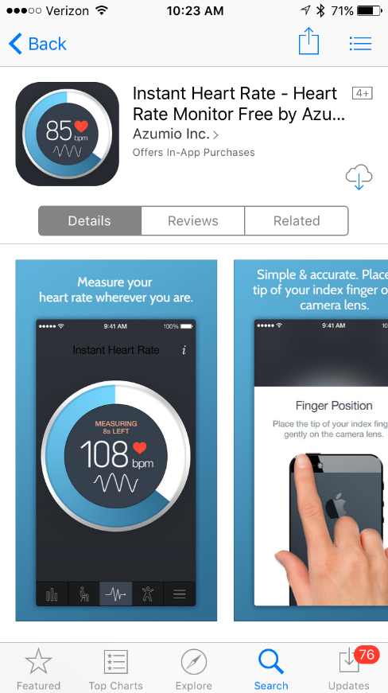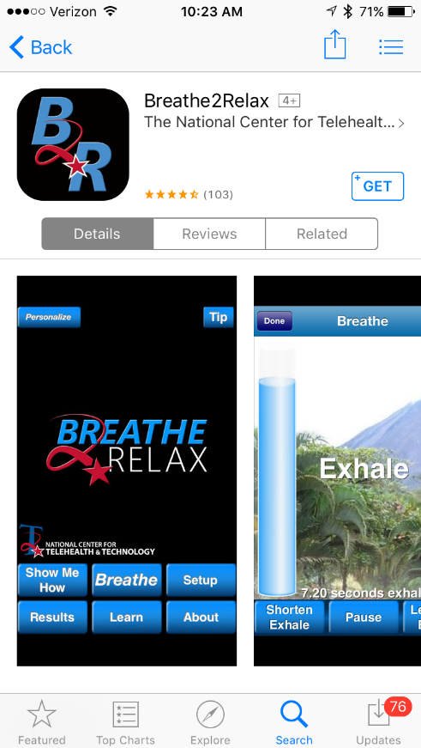

Tracking your Progress and Symptoms:

Daily Heart Rate Survey: https://www.surveymonkey.com/r/3RX6HRD

Performance Day MPA Survey: https://www.surveymonkey.com/r/39P6VYM

TREATMENT 2 (Clarinetist – Sam)

Calm breathing (diaphragmatic breathing), muscle relaxation, and mental imagery are all techniques that may benefit you with your MPA. We found that these treatments are common among many musicians, yoga practitioners, and even new-born babies who naturally exhibit this technique. Below we’ve put together descriptions of these techniques that we’d like you to do before you go out and there and perform!

Based on your e-mail response and MPA index scale, we edited our techniques to better help with your symptoms. Below you will find the edited information highlighted.

*Technique 1:
Muscle Relaxation:
In order to quell shakiness, we are hoping for you to incorporate a muscle relaxation technique involving your hands. This can be done twenty minutes or so prior to performance, either before or after breathing exercises.
This exercise can be done as follows:
Take a deep breath in, and tightly squeeze the muscles in your hand for about five seconds, and then release while breathing out. Repeat this on different parts/ muscles of your hands, tightening and then releasing tension. After your one hand, hopefully, feels more relaxed, continue onto your other hand.

*Technique 2:
Meditative Breathing:
Duration: 10 to 15 minutes prior to performance or warm up
How to: Using a breathing app, take 5 to 10 minutes before performance, to focus on taking calming breaths.
Tips
Calm breathing involves taking smooth, slow, and regular breaths. Sitting upright is usually better than lying down or slouching, because it can increase the capacity of your lungs to fill with air. It is best to 'take the weight' off your shoulders by supporting your arms on the side-arms of a chair, or on your lap.

1. Take a slow breath in through the nose, breathing into your lower belly (for about 4 seconds)
2. Hold your breath for 1 or 2 seconds
3. Exhale slowly through the mouth (for about 4 seconds)
4. Wait a few seconds before taking another breath

About 6-8 breathing cycles per minute is often helpful to decrease anxiety, but find your own comfortable breathing rhythm. These cycles regulate the amount of oxygen you take in so that you do not experience the fainting, tingling, and giddy sensations that are sometimes associated with over breathing.

*** You can combine the muscle relaxation and breathing techniques together. You can do this by breathing in and performing the muscle tension and then breathing out and releasing the muscles. You can do this about thirty minutes prior to your performance.

APPS TO DOWNLOAD AND USE:
breath2relax :: this is a breathing app to help your breathing techniques
HeartRateFree :: this app will measure your heart rate & you can share your results
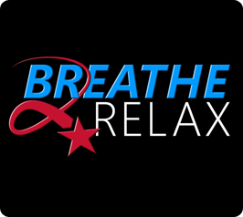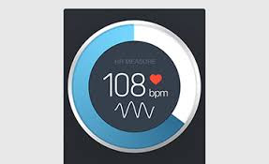

*Technique 3
Mental Imagery
So, since you are not nervous with an audience but you do feel this way when you are one-on-one with a judge, we suggest that you “mentally imagine” that the judge is in the audience at your concerts. We are hoping that this will help to reduce your concern with being judged by someone who knows the music, since you are so comfortable with the large audiences, associating the comfort you have with a large audience will transcend to your solo judged performances. Here’s a link with steps for mental imagery:
https://www.psychologytoday.com/blog/the-integrationist/201306/7-tips-creating-positive-mental-imagery

***MEASUREMENTS
We would like for you to use the heart rate app to measure your heart rate before your breathing and muscle relaxation techniques and after you implement these techniques.
We will also like you do to a journal/blog (just type it up on your phone or do a voice memo) of how you are feeling before these techniques and after your performance
Ex. Day 1 (before feelings) (after feelings)
We would like for you to journal once a week about your feelings about your musical performance and any anxiety, apathy, or excitement experienced. You could send us these journal entries sometime on Sundays.

TIPS:
We also want to share some dietary suggestions:
- Avoid caffeinated foods and drinks, as these can increasre heart rate and anxiety. It may also be helpful to drink some decaffeinated tea, such as chammomile, to induce calming effects
- Finally, eating dry and salty foods, such as crackers, may help with your overactive salivation.

Practicing calm breathing, muscle relaxation, and yoga can help you relax and redirect any negative thoughts or performance anxiety. It is best to practice one of these relaxation techniques every day regardless of whether you have a performance or not so that the skill is there when you need it.

If you have any questions feel free to contact us by email or phone.

Tara Klimeck
706 304 6365
klimeck_tara@columbusstate.edu

Becca Calder
770 530 4243
Calder_rebecca@columbusstate.edu

Vania Martin
770 771 2975
Martinderossi_vania@columbusstate.edu

Treatment Plan 3
(Tracey Carruthers & Stephanie Willamson)

Dear Evgeni,
Tracey and I created a detailed week by week outline instructing you on what tasks you have to complete each week and when. The plan is very simple and easy to understand and both Tracey and I will be following up on your success of these task each week as well. Included in this email, is a document that will allow us to measure your anxiety in a friendly and approachable manner. The measurement is a smiley face anxiety scale that we will be using to keep track of your MPA over the next 9 weeks. These and other additional documents will all be found in this email that we have sent to you. Before and after you implement the treatments, pick a smiley face on the scale that best represents your anxiety level. Next, fill in your number on the spreadsheet that Tracey will email to you on a separate email. Please pick a smiley face every day, even on the days you do not have practice. When you are applying these treatments, it is especially important to use this scale before and after you participate in the treatments, as well as before you practice/perform. The spreadsheet is already made and is organized so that you can input your mood on a daily basis so we can keep track of your anxiety levels throughout treatment. There is nothing else you need to enter on the spreadsheet except that number that you picked on the smiley face anxiety scale. Attached to each week is available links if needed for the treatment plans. Internet access is required for the second half of the treatment, I suggest using the CSU library if you do not have access individually. Please email us if you have any follow up questions. Tracey and I are going to make this outline as detailed as possible for your convenience. Thank you for taking the time to be involved in this project and we hope it improves your MPA dramatically.

WEEK 1 (FEB 22-28): For this week, we wanted to create a baseline that will give us a better idea of how severe your MPA is. We decided to use a pre-existing thought log for you to input your information into on a daily basis before practice and 30 minutes before performance and immediately after performance. This thought log form can be found in this email we sent you which will also have all the other documents you need labeled “thought log”. Do not fill out the last column labeled “Alternative Response”.

WEEK 2 (FEB 29-MAR 6): For this week, you will begin breathing exercises and positive thinking. Breathing exercise paired with positive thinking create a stable environment for your creative talent to shine. When you slow down your breathing and focus on one word, actively using positive thoughts can have a significant impact on your perspective. You can find the exact instructions on your breathing exercises on the email we sent you with all of the other documents labeled “Breathing exercises”. While doing these breathing exercises, we thought it best to give you 5 positive messages to tell yourself once your breathing exercises commence. You can also find the 5 positive thinking messages document in that same file that includes the breathing exercises.

WEEK 3 (MAR 7-MAR 13): For this week, discontinue all treatment plans.

WEEK 4 (MAR 14-MAR 20): For this week, re-continue the breathing and positive thinking treatments exactly as you did on week 2.

WEEK 5 (MAR 21-MAR 27): For this week, you will be using the internet to access a program called the Neuro Programmer 3. I have directly attached the link to the download below. Tracey and I explained this program in minimal detail to you before. In case you wanted more detail, the NP3 was selected in this treatment process because it was easily accessible and has great potential to alter your state of mind by gradually influencing your brainwaves to operate at a level that is best suited for music performance. Simply hit the download button and follow the download instructions. Listen to the sound files related to anxiety and relaxation, or focus 30 minutes before performances and daily this week 30 minutes before practice, and in the background during solo practice. I also attached a safe link that shows step by step on how to use the program that comes complete with pictures as well. This NP3 download is a 2 week trial so be aware of that as well.

Neuro Programmer 3 download link: https://www.transparentcorp.com/products/np/
Step by step instructions link: https://www.transparentcorp.com/products/np/images.php

WEEK 6 (MAR 28- APR 3): Discontinue NP3, as well as all other treatment given to you in previous weeks.

WEEK 7 (APR 4-APR 10): For this week, Tracey and I want you to use a program called Brainwave Generator 3.1. We discussed this program in detail as well with you. This program is very simple to use as well and requires internet access as well. I attached a download link as well. Once you download the file, follow the instructions and the program will make sure the computer you are using is compatible. This as well as the NP3 are safe downloads. Unlike the NP3 however, this is a free download. Listen to the sound files that relate to anxiety, relaxation, and focus 30 minutes before performances and daily this week 30 minutes before practice, and in the background during solo practice.

Brainwave Generator 3.1 download link: download file labeled bwgen31.exe
http://www.bwgen.com/download.htm

WEEK 8 (APR 11-APR 17): Discontinue BG 3.1, as well as all other treatment given to you in previous weeks.

WEEK 9 (APR 18-22): For this week, more information will be given out during the previous week.

Anxiety Scale

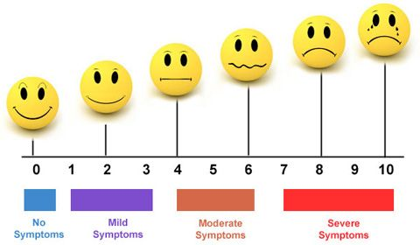

0 = No anxiety (feeling calm)
1 = Slight anxiety (passing pain of anxiety, feeling slight nervous)
2 = Mild anxiety (butterflies in stomach, nervous, negative self- talk starts)
3= Mild anxiety (feeling uncomfortable but still in control, heart starts to beat faster, more rapid breathing, trembling hands)
4= Moderate anxiety ( feeling uncomfortable, heart beating fast, beginning to wonder about maintaining control, feeling nauseous, trembling body parts or shaking hands)
5= Early panic (heart pounding or beating irregularly, limited breathing, definite fear of losing control, unable to think clearly, pressure to escape)
6 = Moderate panic anxiety (palpitations, difficulty breathing, feeling disoriented or detached (feeling of unreality); panic in response to perceived loss of control)
7-10 = All of the symptoms in level 6 exaggerated; loss of control of my body and throwing up; pressure to escape.

͙ derived from http://anxiousnomore.blogspot.com/2007/05/anxiety-scale.html
Positive things to say (5 minutes before practice/performance):
- I am great performer
- I have years of experience, I can overcome this performance
- I prepared for hours, I am more than ready for this performance
- Just focus on the music, not the audience
- I can only control how I perform, everything else is not in my control
- Just breathe slowly and relax.

Breathing exercise
While breathing try to focus on one positive statement (from above)
Practice the day before the show and 5-10 minutes before performance!
Instructions: Deep Breathing

- Sit comfortably in your chair. Place your hand on your stomach so you are able to feel your diaphragm move as you breathe.

- Take a deep breath through your nose. Breathe in slowly. Time the breath to last 5 seconds.

- Hold the breath for 5 seconds. You can do less time if it's difficult or uncomfortable.

- Release the air slowly (again, time 5 seconds). Do this by puckering your lips and pretending that you are blowing through a straw (it can be helpful to actually use a straw for practice).

- Repeat this process for about 5 minutes, preferably [2] times a day.

Video that illustrates the breathing exercise: https://www.youtube.com/watch?v=EYQsRBNYdPk

*Derived from http://www.therapistaid.com/therapy-guide/cbt-for-anxiety/none/none

Strategies to reduce MPA symptoms (Treatment Plan 4)
Psychology Students: Amanda Locken and Stephanie Fisher
Music Student: Michael Korwek

To help you in treating your MPA, will be asking you to participate in light to moderate exercise and focus on your breathing by using a guided meditation while walking, before practice and before performances.

- Instructions:
  - Walking
As per our conversation we would like you to take a walk lasting between ten and thirty minutes. Please aim to take a walk at least four times a week. We want this to be a time away from work or school where you focus solely on the walk and being present. Being present meaning that you would focus on your breathing and immediate surroundings. This is not the time to think about performing, the show you’ve been watching, or tasks you need to complete at work. Be safe. If you do not have a safe place to walk please do not put yourself in danger.
  - Meditation
Attempt to make the “Breathing Butterfly” app, the app that we helped you download, a part of your routine before you practice and before you perform. We also want to encourage you to use the app in a relaxing setting on days where you do not practice or perform. You mentioned not being anxious in your practice space or during practicing. Our goal is for you to develop a ritual to use before you perform and practice. Ideally you will use our suggested guided meditation for a few weeks until you feel comfortable making your own ritual to use before practicing and performing.
  - Measuring
We would like you to record, using a voice memo, your level of anxiety. The scale below can be used to rate your level of anxiety.
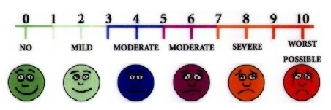
We would like you to record your anxiety level in various situations to better understand the effectiveness of our treatment plan. The several different situations are: no more than 15 minutes before your performance, no more than 30 minutes after your performance, immediately before your walk or meditation, and immediately after your walk or meditation. We will also be using the anxiety levels you recorded before and after your performance at First Baptist Church that occurred before you started our suggested treatment.

  - Habits
Continue to journal, meditate, and bike as you normally do.
TREATMENT PLAN 5
Students: Lauren Martin and Abigail Cox

Hey Sandi, this is our final therapy design and hopefully it will help you to be less anxious. There will be a few things we need from you, but its minimum and it is only because we need to know if the therapy is being implemented and if it is working.

Final Therapy Procedures:
The symptom we are going to focus on is the psyching out/second guessing oneself. To combat this we are going to use a design of Acceptance and Commitment Therapy or ACT for short, this will replace the second guessing of yourself with a thought to help you get through the performance.
The way this will work is that when you realize you’re having these thoughts you’re going to stop yourself and repeat the following.
“I might mess up and that is okay, I’m human.”
Or
“What’s the worst that can happen if I mess up?”
This is the Acceptance part of the therapy, the next part comes during the performance. Even though you know you MIGHT mess up, you have to commit to the performance and follow through.
We also want to combine the ACT above with breathing techniques. The one listed below should help you in calming yourself down when you feel that nauseas feeling rising up and when your anxiety starts to take hold.
- Exhale completely through your mouth, making a whoosh sound.
- Close your mouth and inhale quietly through your nose to a mental count of four.
- Hold your breath for a count of seven.
- Exhale completely through your mouth, making a whoosh sound to a count of eight.
- This is one breath. Now inhale again and repeat the cycle three more times for a total of four breaths.
The things we need for you as that at each time your anxiety “flares up” we would like for you to either write how you are feeling or use a voice memo app on your phone. This is up to YOU, whichever one you feel most comfortable with. We will need to use these as a measurement. Also in each log you keep, we will need a rating following something like the scale below.
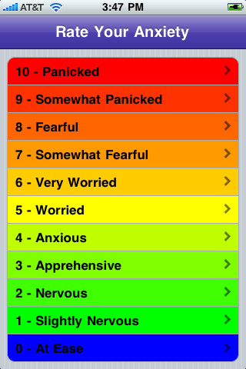
We really hope this works and we look forward to your feedback. If anything is too complicated or you have questions please email me. Also if you could do each of the logs every time you feel anxious and rate it, it would be greatly appreciated. This is so we can see if the treatment is actually working!

MPA Treatment Plan 6
Treatment | How often | Details | How measured | What we hope it does
Yoga | - 3 times a week  - About 30 minutes each time | - IMPORTANT: No matter which yoga you choose, have a recording of yourself playing to listen to as you workout  - 30 days of Yoga with Adrienne:  - https://www.youtube.com/watch?v=oBu-pQG6sTY  - We do not expect you to do these 30 days in a row  - Yoga class video for musicians (50 min):  - https://www.youtube.com/watch?v=BvO5LlFdIZU  - If you do not enjoy or do not want to do these options we encourage you to find another one, just let us know what it is! | We will ask you about how this is working for you and you can write details about it in your general. We will also compare MPA Inventory scores before and after entire treatment. | - Relaxation  - Less anxiety overall  - Focus  - *This feelings to be paired with hearing and, hopefully, playing your music
Mental Skills Training | Before each time you play, practice or performance  AND/OR  At the beginning of the day | *These steps are provided below. You can take out phrases or add them as needed, just give us an idea of what you are thinking or saying each time* | We will talk with you about how this worked and get self-reports. Any thoughts or comments can also be recorded in journal | - Focus  - Confidence  - Being prepared and feeling prepared  - More positive (and probably more accurate ) idea about the audience’s perspective of your playing
Cognitive Restructuring | During practices, auditions, and performances | A-E Process, see below | Self-reports again and journal, if desired | - Helps you return to focus  - Helps you to make yourself really be in the moment and enjoy the experience (hopefully!)  - Builds confidence less mistakes, more enjoyable!
Journaling | Once daily, or as often as desired | Journal about practices, performances, and treatments  We would really like you to focus on trying to record the experience of playing, as a way to practice remembering it  *You could also record other things if you would like! | Reading journal and discussing | - First, we hope that recording details about performances and expecting to have to record them will help you to remember more and focus while playing.  - Also, journaling in general has been known to lower anxiety.

Mental Skills Training before practice or performance
- Breathing: breathe deeply and slowly
  - Inhale. Hold for 5 seconds. Exhale. Repeat several times
- Attitude and Self-Talk
  - Think positively about yourself.
  - Tell yourself:
    - Anxiety is a part of performing. It helps me to perform well.
    - I am prepared. I have practiced many times.
    - I am talented and confident in my abilities.
    - I know what to do.
- Goals (pick 1 or 2)
  - What are my goals for this performance?
  - What do I want to accomplish?
- Audience
  - They want me to do well.
  - They enjoy listening to me.
- Mental Imagery
  - Imagine yourself playing the piece in as much detail as possible. Think of a specific part that is very difficult. Imagine playing it well. Make the movements your fingers would make. Breathe as if you have been playing. Imagine that you are doing a wonderful job and that many members of the audience are smiling.
- Concentration
  - Think about how you feel when you play. Think about why you enjoy it, what your favorite parts are.
  - Focus again on your breathing for a few moments.

Cognitive Restructuring
Two parts:
- Recognize negative/harmful thoughts that you have during any practice or performance
Replace these thoughts with positive ones

- Expand this process after performances through the journals.
During this part you will try to identify:
- Antecedent event: for example a particular person listening or a difficult piece you have to play; precedes behavior
- Behavior: whatever negative thought you have
- Consequence: how that negative thought affected you, maybe with increased anxiety or by making more mistakes).
- Dispute: See what evidence there is to support or disprove whatever negative thoughts you may have initially had
- Explanation: provide a more rational (hopefully more positive!) thought towards the situation
These “A-E” steps are basically what we hope will be happening as you change your thinking while playing. The idea is that as you are playing the responses and change in thoughts from positive to negative will occur quickly and then writing about them later will help you practice the behavior.

TREATMENT PLAN 7
Skye Geeslin and Matthew Reeves

Here is the finalized treatment program to address your music performance anxiety. We focused on the primary issues of self-deprecation before sight reading and other high pressure performances, and shoulder tension during practices and performances. We have developed a 3-part program, which includes increasing sight reading practice, raising awareness of muscle tension, and thought replacement therapy to change your thought pattern to reflect more positive thoughts.

Measures
- Take Anxiety Assessment before treatment begins, and after program completion.
  - The anxiety assessment will give the researchers a general idea of anxiety levels before onset of treatment, and will help in assessing whether or not overall anxiety was changed at the end of the program.
- Thought record will be used to assess the success of the cognitive restructuring therapy on self-deprecating thoughts.

Treatments

- Sight Reading Practice- at least 1 hour per week
  - www.sightreadingfactory.com this is to help you find a way to practice sight reading in your own time, with pieces that are not currently known to you. (disclaimer: This site gives you a limited number of uses before asking you to sign up and pay)
  - www.clarinet-now.com (this one is free)

Reasoning: In order to reduce your anxiety before sight reading sessions, we
recommend increasing your confidence with sight reading through an increase in sight reading practice. Studies have consistently shown that increasing practice can increase confidence in performance.

- Breaks and Muscle Awareness Cues
  - Take a 30sec mini-break every 15min when practicing to check for shoulder tension, during the first week. After the first week, if you feel that the tension is lessening, extend the timer, but by no more than 5min. For example, during week 2 the timer could be set for 20min, week 3 timer could be 25 min, etc.
    - If shoulder tension is present,
      - Take a deep breath
      - relax shoulders, roll them back and down.
      - Lengthen spine (imagine there is a string attached to the top of your head that is pulling you upward).
  - Take a 5-minute break for every 30-min that you play. During this longer break, stand up, walk around, and stretch out all of your muscles.
  - We also feel that it will be beneficial to mark certain places in the pieces of music you are playing, so that the sight of the marks will visually cue you to release any shoulder tension without the need to stop playing. This can also be done for performance pieces as well.
    - When picking the sections of music to mark, try and keep the intervals fairly even between marks. For example, it should take you roughly 3 min to play from one mark to another, throughout the piece. Just pick an interval that you feel is comfortable, and stick with it.

Reasoning: To address your reported shoulder tension during solo repertoire
practice and during performances, we want to raise your awareness
of the issue. To do this, we ask that during practice you set a timer
for the amount of time indicated above. When the timer goes off,
consciously check for shoulder tension, and use the above
instructions to correct it. This serves to raise your awareness of the
problem, and over time you should be able to notice and release the
shoulder tension without the aid of a timer or reminder.

- Cognitive Restructuring
  - Fill out thought record whenever you are in an anxiety provoking situation (i.e. before a performance, audition, or during solo repertoire practice)
  - The thought record is both a measure and a treatment. It it used as a way to consciously recognize and record the self-deprecating thoughts. It also serves to assist you in coming up with reasons why the thoughts are irrational, and replacing them with positive, self-affirming thoughts.
    - Step 1. AWARENESS: consists of 3 steps.
      - Identify and acknowledge the stressor.
      - Identify why these situations and events are stressors.
      - Appraisal to the main stressor.
    - Step 2. REAPPRAISAL OF THE SITUATION:
      - A “second opinion” you generate in your mind to offer a different (objective) viewpoint.
      - Ask yourself “If this was a friend saying this to me about themselves, what would I say to them?”
    - Step 3. ADOPTION AND SUBSTITUTION:
      - Once a new frame of mind is created, it must then be adopted and implemented.
      - Pick a positive phrase or affirmation that means something to you, that you can use to replace the negative thought.
        - Phrase your affirmation in the present tense such as “I am a talented player.”
        - Phrase your affirmation in the MOST positive way.
        - Make your affirmation simple, clear, and precise.
    - Step 4. EVALUATION:
      - Measure effectiveness of new positive perspective. Ask yourself, “Did this new attitude work?”

Reasoning: In order to address your primary issue, the self-deprecating
thoughts, we have developed a procedure to raise your
awareness of the thoughts, and force you to address them.
By addressing the thoughts, you will be able to consciously
realize why they are wrong, and replace them with more
self-affirming thoughts. When done consistently, it has
been shown to reduce overall anxiety and increase a
person’s self-efficacy.

TREATMENT PLAN 8
Brittany McRae, Mary Rodriguez, and Alexis Woods

Here is the finalized treatment program to address your music performance anxiety. We focused on the primary issues of self-deprecation before sight reading and other high pressure performances, and shoulder tension during practices and performances. We have developed a 3-part program, which includes increasing sight reading practice, raising awareness of muscle tension, and thought replacement therapy to change your thought pattern to reflect more positive thoughts.

Measures
- Take Anxiety Assessment before treatment begins, and after program completion.
  - The anxiety assessment will give the researchers a general idea of anxiety levels before onset of treatment, and will help in assessing whether or not overall anxiety was changed at the end of the program.
- Thought record will be used to assess the success of the cognitive restructuring therapy on self-deprecating thoughts.

Treatments

- Sight Reading Practice- at least 1 hour per week
  - www.sightreadingfactory.com this is to help you find a way to practice sight reading in your own time, with pieces that are not currently known to you. (disclaimer: This site gives you a limited number of uses before asking you to sign up and pay)
  - www.clarinet-now.com (this one is free)

Reasoning: In order to reduce your anxiety before sight reading sessions, we
recommend increasing your confidence with sight reading through an increase in sight reading practice. Studies have consistently shown that increasing practice can increase confidence in performance.

- Breaks and Muscle Awareness Cues
  - Take a 30sec mini-break every 15min when practicing to check for shoulder tension, during the first week. After the first week, if you feel that the tension is lessening, extend the timer, but by no more than 5min. For example, during week 2 the timer could be set for 20min, week 3 timer could be 25 min, etc.
    - If shoulder tension is present,
      - Take a deep breath
      - relax shoulders, roll them back and down.
      - Lengthen spine (imagine there is a string attached to the top of your head that is pulling you upward).
  - Take a 5-minute break for every 30-min that you play. During this longer break, stand up, walk around, and stretch out all of your muscles.
  - We also feel that it will be beneficial to mark certain places in the pieces of music you are playing, so that the sight of the marks will visually cue you to release any shoulder tension without the need to stop playing. This can also be done for performance pieces as well.
    - When picking the sections of music to mark, try and keep the intervals fairly even between marks. For example, it should take you roughly 3 min to play from one mark to another, throughout the piece. Just pick an interval that you feel is comfortable, and stick with it.

Reasoning: To address your reported shoulder tension during solo repertoire
practice and during performances, we want to raise your awareness
of the issue. To do this, we ask that during practice you set a timer
for the amount of time indicated above. When the timer goes off,
consciously check for shoulder tension, and use the above
instructions to correct it. This serves to raise your awareness of the
problem, and over time you should be able to notice and release the
shoulder tension without the aid of a timer or reminder.

- Cognitive Restructuring
  - Fill out thought record whenever you are in an anxiety provoking situation (i.e. before a performance, audition, or during solo repertoire practice)
  - The thought record is both a measure and a treatment. It it used as a way to consciously recognize and record the self-deprecating thoughts. It also serves to assist you in coming up with reasons why the thoughts are irrational, and replacing them with positive, self-affirming thoughts.
    - Step 1. AWARENESS: consists of 3 steps.
      - Identify and acknowledge the stressor.
      - Identify why these situations and events are stressors.
      - Appraisal to the main stressor.
    - Step 2. REAPPRAISAL OF THE SITUATION:
      - A “second opinion” you generate in your mind to offer a different (objective) viewpoint.
      - Ask yourself “If this was a friend saying this to me about themselves, what would I say to them?”
    - Step 3. ADOPTION AND SUBSTITUTION:
      - Once a new frame of mind is created, it must then be adopted and implemented.
      - Pick a positive phrase or affirmation that means something to you, that you can use to replace the negative thought.
        - Phrase your affirmation in the present tense such as “I am a talented player.”
        - Phrase your affirmation in the MOST positive way.
        - Make your affirmation simple, clear, and precise.
    - Step 4. EVALUATION:
      - Measure effectiveness of new positive perspective. Ask yourself, “Did this new attitude work?”

Reasoning: In order to address your primary issue, the self-deprecating
thoughts, we have developed a procedure to raise your
awareness of the thoughts, and force you to address them.
By addressing the thoughts, you will be able to consciously
realize why they are wrong, and replace them with more
self-affirming thoughts. When done consistently, it has
been shown to reduce overall anxiety and increase a
person’s self-efficacy.

TREATMENT PLAN 9
Hi Brennan,
Tips:
1. Mental Imagery:
This is a two-thought process. First, think of a performance where you did really well and the feelings that were associated with that particular performance (beforehand and afterwards). Secondly, if you are having negative thoughts about an upcoming performance, then verbally tell yourself to stop and attempt to block out unhelpful thoughts. Channeling good thoughts should help increase your confidence in your abilities and also help decrease your anxiety levels.
Here is a link for help:
http://web.b.ebscohost.com/ehost/detail/detail?sid=a3d068a3-fc6a-486e-9476-4f3831826006%40sessionmgr120&vid=0&hid=116&bdata=JnNpdGU9ZWhvc3QtbGl2ZQ%3d%3d#db=pdh&AN=2011-20583-001

- This technique is for you to do for practices, Friday studio performances, and public performances. Basically whenever you are experiencing anxiety, you can use this technique to help calm you down and channel good thoughts.

2. Yoga breathing techniques (beginner level)
Try to do these breathing techniques consistently (whenever you can). You can use a shortened version the same day of your performance to help with your breathing and monitoring your heart rate and the shaky feeling you get in your hands and feet.
Here is a link for help with this strategy:
https://www.youtube.com/watch?v=QJ-5YzBZdrI

3. Dry Mouth Tips:
- Chewing sugar free candy (same day of performance too)
- Limit your caffeine intake because it can make your mouth drier
- Sipping water regularly
- Avoid sugary or acidic foods
- Breathing techniques: http://www.drweil.com/drw/u/ART00521/three-breathing-exercises.html
- 4,7,8 breathing exercise demonstration: http://www.drweil.com/drw/u/VDR00160/Dr-Weils-Breathing-Exercises-4-7-8-Breath.html

Measurement:

1. We will have you do these techniques daily.

2. As a way to track your progress, we would like for you to keep a journal or daily log that you can write in at the end of the day.
-track your sleeping patterns (how many hours of sleep you’re getting per night; is your sleep interrupted; etc.
-report the daily times that you actually used the techniques and detail how it is working for you
-We are asking you to use the scale below to measure your anxiety before and after your performances (practices and studio performances too if you get nervous during those as well)
-Also, when you mark a number, try to elaborate on what you are feeling
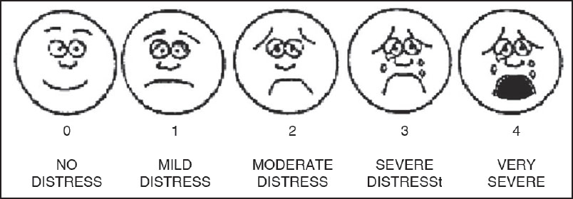

** You will send your log or journal entries to us by the end of the week throughout the duration of this project so we can keep progress of how everything is working.

* Fun thing: If you would like to do this, you can set some realistic, attainable goals that you are trying to accomplish when it comes to your music performance and anxiety BEFORE you start the techniques and then we can review them at the end of this project and see how everything has worked out for you. You can just keep those at the front of your journal and we will review it again at the end of this project.

