Shadows

Each morning I appear
To lie at your feet,
All day I will follow
No matter how fast you run,
Yet I nearly perish
In the midday sun.

How long is a shadow?

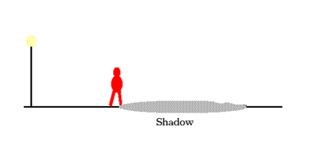
Make a list of all of the variables this could exist in the above situation.

Identify all of the variables on a diagram.

Which variables could be independent variables?

Which variables are dependent on something else?

The picture below shows the variables that we will consider in these explorations.

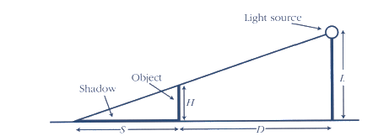

Experiment 1 – Varying D.

Set up your light at a height that you choose. L = _________

Use your cubes to construct a tower to serve as H and measure its height. H = _______

What will be the independent variable you are controlling?

What will be the dependent variable you are measuring?

Collect data by conducting careful measurements.

L | H | D | S | D+S

Look for relationships in your data. You might graph pairs of variables or you might look for patterns in sums, differences, products, or quotients.

Try and determine a function rule that relates two variables.

Be prepared to report to the class any discoveries you made.

Experiment 2 – Varying H.

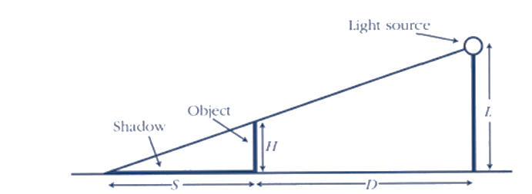

This time you will keep everything constant and vary H. Select a value for D that gives you a nice shadow that is easy to measure.

L | H | D | S | D+S

Look for relationships in your data. You might graph pairs of variables or you might look for patterns in sums, differences, products, or quotients.

Try and determine a function rule that relates two variables.

Be prepared to report to the class any discoveries you made.

Experiment 3 – Varying L

This time you will keep everything constant and vary L.

L | H | D | S | D+S

Look for relationships in your data. You might graph pairs of variables or you might look for patterns in sums, differences, products, or quotients.

Try and determine a function rule that relates two variables.

Be prepared to report to the class any discoveries you made.

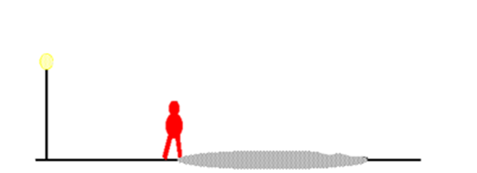

Draw and label a mathematical model of the situation using the picture above.

Identify and similar triangles.

How do you know that these triangles are similar?

Using what you know about similar triangles, write as many different proportional relationships as you can that are true about the situation.

Choose a set of numbers from each of the experiments that you did earlier. Draw and label a model for each of the experiments and verify whether or not one of the proportions you wrote holds for that situation.

Using what you have discovered, write a formula that could be used to find S if you knew all of the other variables.

Sun Shadows
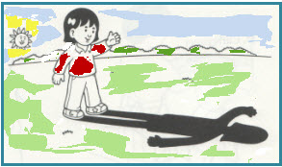

We’ve devised a model that works well for shadows cast by streetlights at night. Why won’t this model work for shadows from the sun?

How could we devise a model that uses similar triangles to find the height of an unknown object using shadows?

Experimenting with light and mirrors
Mirror, Mirror on the Wall Floor

In this experiment you’ll explore the angles involved in how light bounces off of a mirror.

You’ll need:
Several sheets of blank paper
A laser pointer or flashlight
Ruler or straightedge
Protractor

- Set up the mirror along the edge of a sheet of paper as shown in the picture below.
- Use the straightedge to draw a line that intersects the mirror.
- Shine the laser pointer along the line that you drew so that it hits the mirror at the point where the line intersects the mirror.
- Have your partner mark where the image of the laser bounces back onto the paper.
- Use your straightedge to draw the bounce back line.
- You will have formed three angles. Measure each of these angles
- Repeat several times with a new sheet of paper and vary the angle of your initial starting line segment.
- What do you observe about the angles?

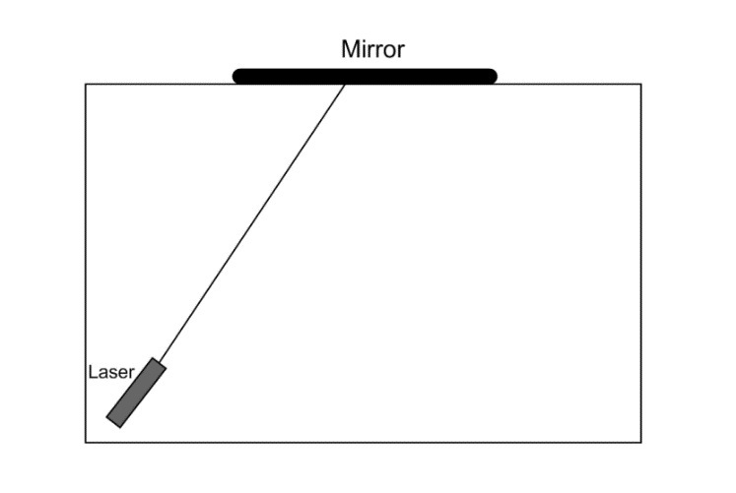

Bugs on a Wall


Poor little bug on the wall
No one to love him at all
No one to wash his clothes
No one to tickle his toes
Poor little bug on the wall

Indirect Measurement with a Mirror

In this exploration, you’ll use a mirror on the floor to find the heights of objects using properties of light reflection and similar triangles.

Show how similar triangles would be formed on the diagram below.

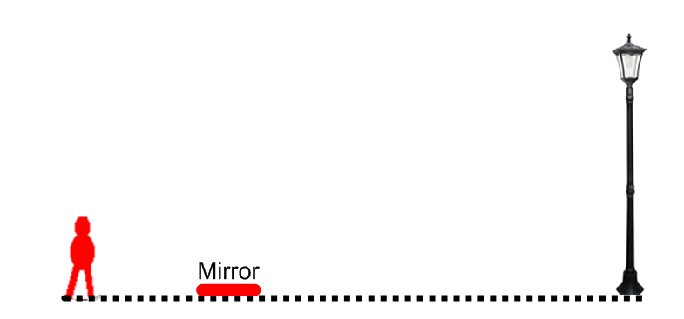
Part 1
Find an object in the room to measure.
Lay your mirror on the ground some distance from the object.
Walk backwards, slowly while looking in the mirror until you can see the object in the mirror.
Work with a partner to measure the things that you need to know in order to be able to find the height of the object.
Swap roles with your partner and repeat the measurements.

Part 2

Place a piece of painters tape or a colored dot somewhere on a wall.
Use the technique above to determine its height.
Measure the actual height and determine your percentage error.

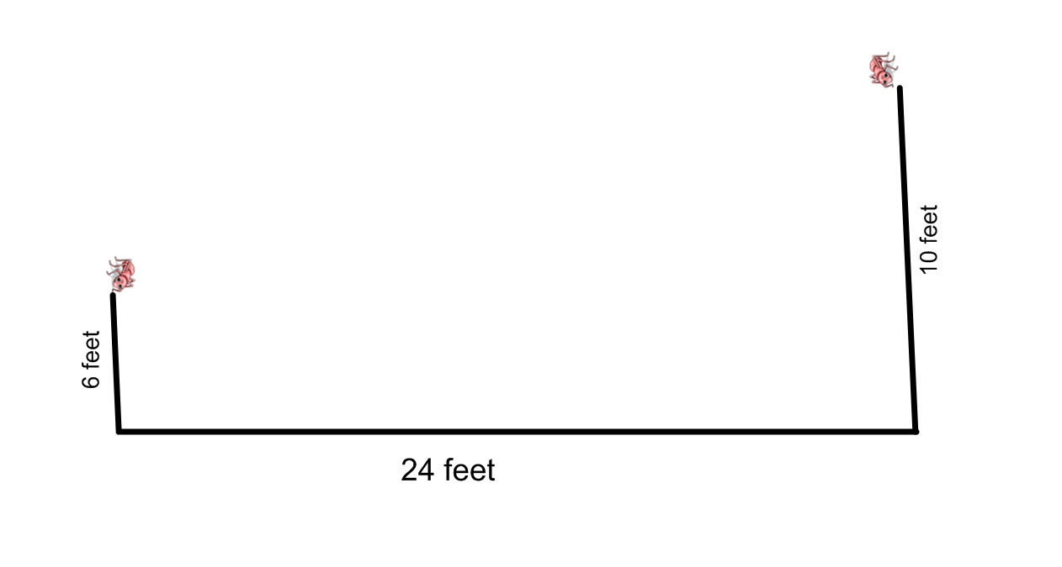
Two ants are on opposite walls of a 24 foot room, as shown. Where should you place a mirror on the floor so that the two ants will be able to see each other?



Fireworks

Exploring Quadratic Functions

A high school sports team has just won the championship. As part of the celebration, the school plans to have a fireworks display. The fireworks will use rockets launched from a tower near the school. The top of the tower is 160 feet off the ground. The mechanism will launch the rockets so that they are initially rising at 92 feet per second.

The team wants to choreograph music to correspond to the fireworks exploding when it is at the top of its trajectory. They need to know how long it will take for the rocket to reach the top so they can set up the timing mechanism.

They also need to know how high the fireworks will go in order to tell spectators of the best viewing location.

A member of the team who is good in algebra says they can get this information using the function $h\left(t\right)=160+92t-16t^{2}$ where h(t) is the height of the rocket in feet and t is the time.

- Help the team figure out the information they need using a graph and a table.
- They are considering purchasing some more powerful rockets for the finale that can launch the fireworks with a higher initial velocity. However there is a city ordinance that the maximum height of the fireworks cannot be over 350 feet.
  - What is the maximum strength rocket they can purchase without violating the ordinance?
  - If they purchase the maximum strength rocket, how long with it take for the fireworks to reach its maximum height?



Finding a Quadratic with Given Roots

Find three different quadratics of the form $y=ax^{2}+bx+c$ that have roots, x = -2 and x = 3.

Verify that these are the roots using a graph and a table.

Find a quadratic with these roots that goes through the point (1, -4)

Quadratics in Context


The St. Louis Arch looks similar to a parabola although it is actually a special type of function called a catenary. For our purposes though we’ll assume that a parabola will sufficiently model the curve.

The arch is 630 feet wide at its base and is 630 feet tall.

Find an equation that models the St. Louis Arch.

Going, Going, Gone—Or Is it?

When a baseball is hit or thrown, it follows a parabolic path. On a very calm day with no wind, Mickey Fireplace hit a powerful drive to left field right over the 3rd base line. When the ball was 175 feet from home plate the ball was at its maximum height of 60 feet.

a. Determine a formula to describe the path of the ball.

b. If the left field fence is 325 feet from home plate, and the fence is 15 feet high, determine whether Mickey’s hit could be a home run (i.e. go over the fence).


Painting Pictures with Quadratics

If the x-scale on the graph below is -10 to 10 and the y-scale is -10 to 10, find the equation of the four parabolas given.

