M & M Math
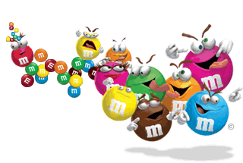
Color | Number | Percent | Calculated Angle | Measured Angle | Difference  (Calculated – Measured)
TOTALS

