Quadratic Representations

Algebra Tiles Algebra Tiles Graph Equations
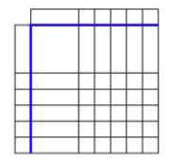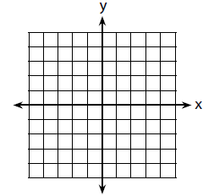

Algebra Tiles Algebra Tiles Graph Equations

