TASK #1A
Pattern Block Patterns

Use Pattern Blocks to build the growing pattern below and answer the questions.

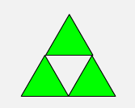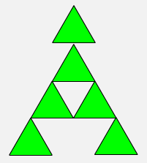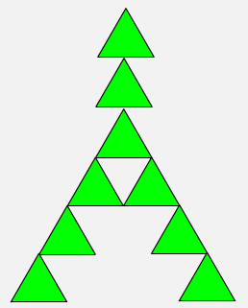

Design #1
Design #3
Design #2

TASK #1B
Pattern Block Patterns

Use Pattern Blocks to build the growing pattern below and answer the questions.

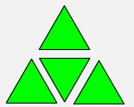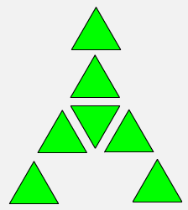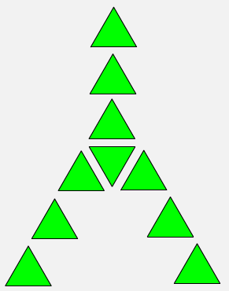

Design #1
Design #2
Design #3

TASK #2A
Color Tile Patterns

Use Color Tiles to build the growing pattern below and answer the questions.

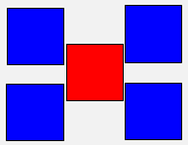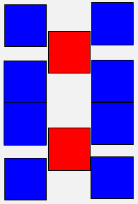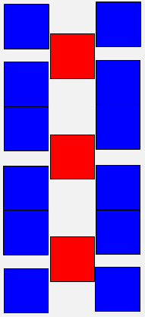

Design #3
Design #2
Design #1

TASK #2B
Color Tile Patterns

Use Color Tiles to build the growing pattern below and answer the questions.

Design #1

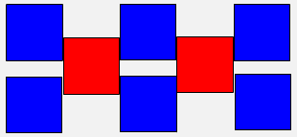
Design #2

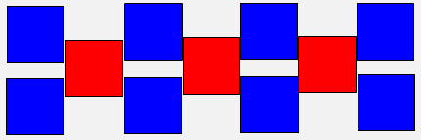
Design #3
TASK #3A
Multilink Cube Patterns

Use Multilink Cubes to build the growing pattern below and answer the questions.

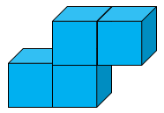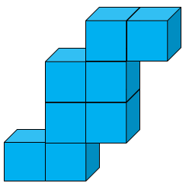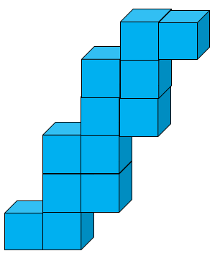

Design #3
Design #2
Design #1

TASK #3B
Multilink Cube Patterns

Use Multilink Cubes to build the growing pattern below and answer the questions.

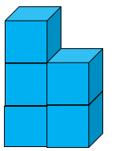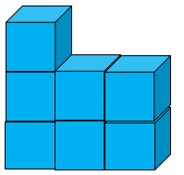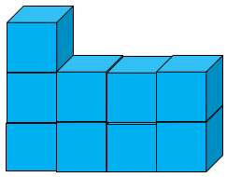

Design #3
Design #2
Design #1
TASK #4A
Cuisenaire Rod Patterns

Use Cuisenaire Rod to build the growing pattern below and answer the questions.

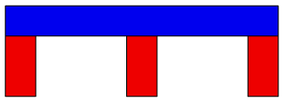
1 Span

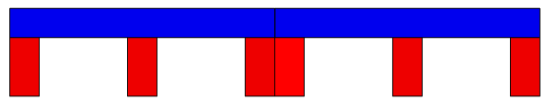
2 Spans

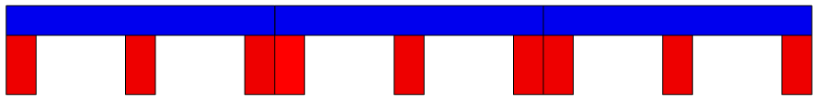
3 Spans
TASK #4B
Cuisenaire Rod Patterns

Use Cuisenaire Rod to build the growing pattern below and answer the questions.

1 Span

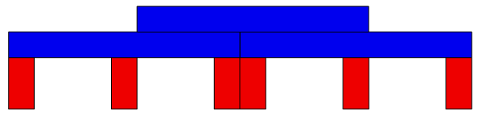
2 Spans

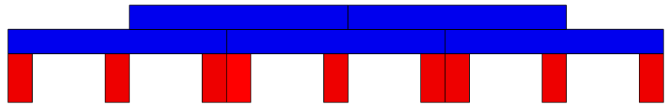
3 Spans

