$$f\left(x\right)=2x-7$$ | $$f\left(x\right)=\frac{x+7}{2}$$
$$f\left(x\right)=3x^{2}-1$$ | $$f\left(x\right)=\sqrt{\frac{x+1}{3}}$$
$$f\left(x\right)=\frac{x-5}{3}$$ | $$f\left(x\right)=3x+5$$
$$f\left(x\right)=\frac{1}{4}x+2$$ | $$f\left(x\right)=4(x-2)$$
$$f\left(x\right)=x^{3}+1$$ | $$f\left(x\right)=\sqrt[3]{x-1}$$
$$f\left(x\right)=6(x-4)$$ | $$f\left(x\right)=\frac{x}{6}+4$$
$$f\left(x\right)=\frac{2}{x}$$ | $$f\left(x\right)=2 (\frac{1}{x})$$
$$f\left(x\right)={10}^{x}$$ | $$f\left(x\right)=\log_{10}{x}$$
$$f\left(x\right)=0.2x-8$$ | $$f\left(x\right)=5(x+8)$$

These cards are just samples. You might want to modify the types of expressions to be appropriate for your course.
Function Cards

For the function card that you have:

- Use words to describe the operations involved and the order in which they get done.
- Find four ordered pairs that belong to the function.
- Identify the domain of the function.
- Identify the range of the function.
- Carefully sketch a graph of the function.

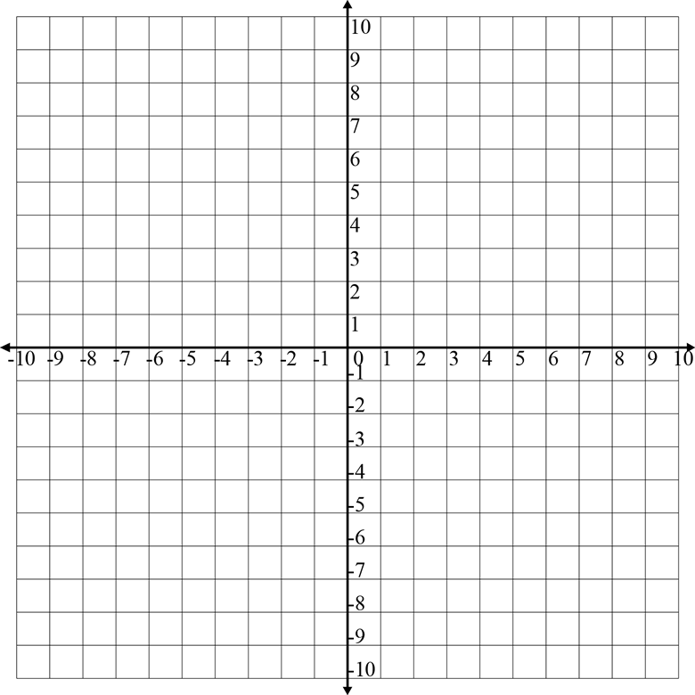

Mystery Functions

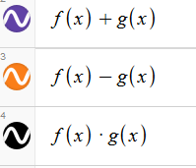
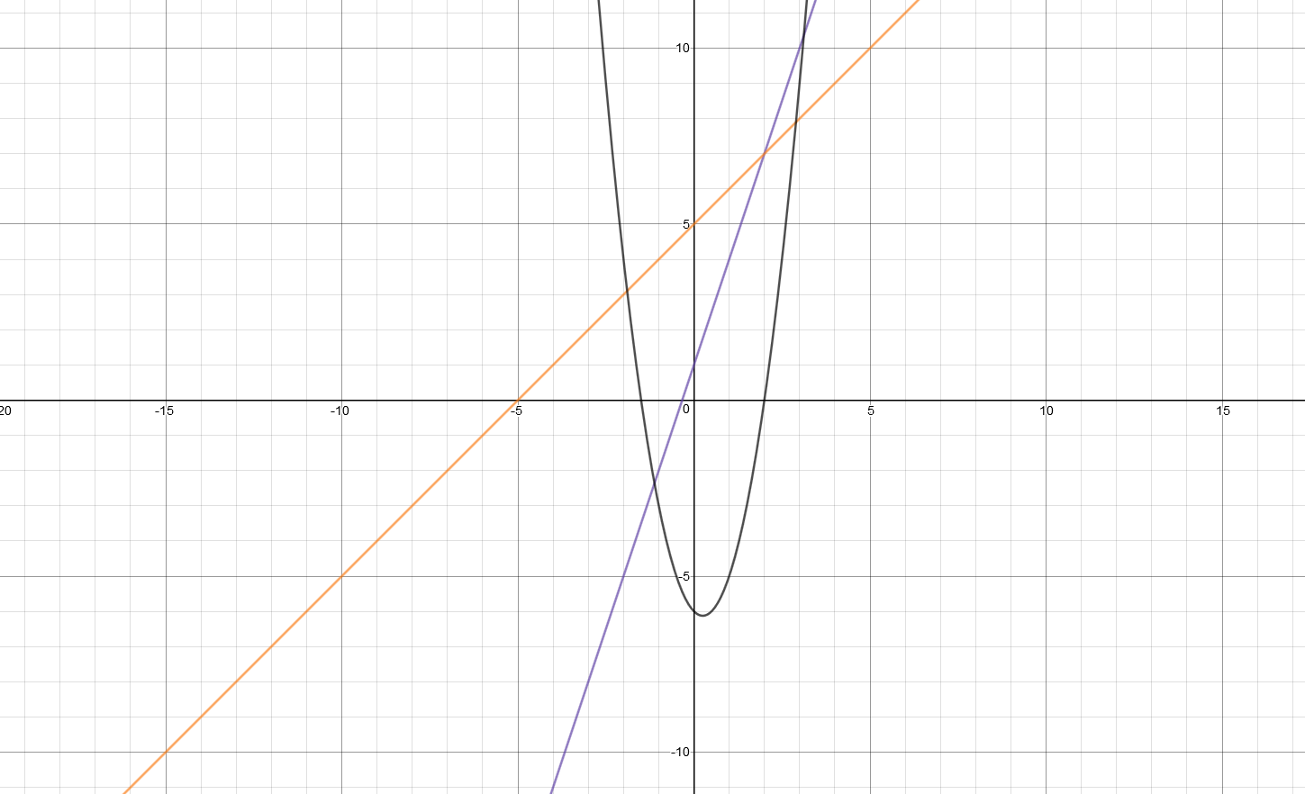

Can you determine rules for f(x) and g(x) given that they are both linear functions?
Mystery Functions

Y₃=Y₁+Y₂
Y₄=Y₁-Y₂
Y₅=Y₁ ∙Y₂

Can you determine Y₁ and Y₂ given that they are both linear?

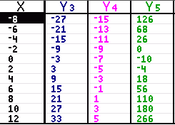

Practice with Inverses

This is the link to the Desmos activity center activity about inverses.

https://teacher.desmos.com/activitybuilder/custom/56490a9249a8c4c90e500219

Student.Desmos.com

