Modeling Indirect Measurement with Similar Triangles

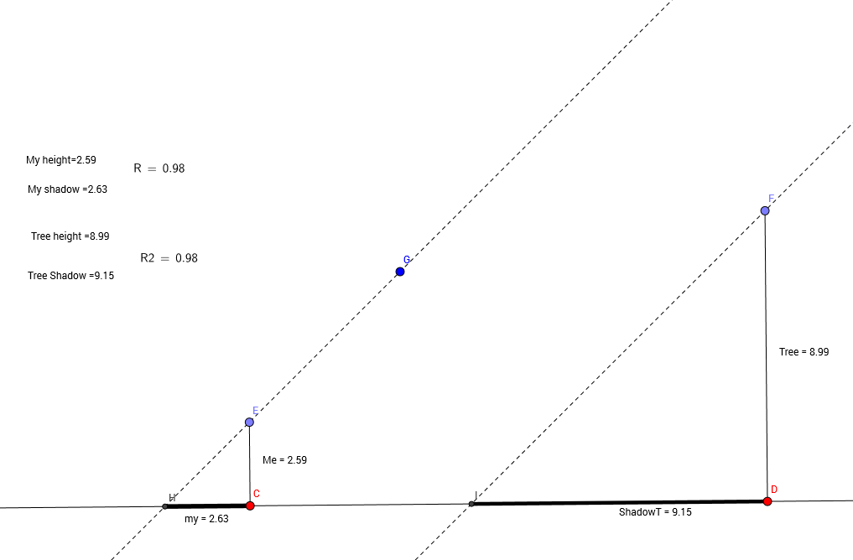

We are going to model using shadows from the sun to find the height of a tall object.

Creating your sketch

- Draw a horizontal line to represent the ground. (Right click on the object and use properties to make it green.
- Construct two free points on the line. This will represent the places where your feet and the roots of the tree meet the ground.
- Construct a perpendicular line through each point.
- Construct a point on each of these perpendicular lines. (Right click on each line and hide the line by unchecking the show object box.)
- Use the segment tool to construct segments from each of these points to the point below them on the ground.
- Right click on each segment and use properties to change the names to “Me” and “Tree”.
- Adjust the heights so that the tree is much taller than you.
- Construct a diagonal line through the point at the top of your head. Click on it and use object properties to make the line dashed. This line represents the sun’s rays.
- Since the sun is so far away, its rays are essentially parallel. Use the construct parallel tool to construct a line through the top of the tree, parallel to the other line. Use properties to make it dashed.
- Use the point intersect tool to construct points where these lines intersect the ground.
- Construct segments that represent each of the shadows. Use the properties tool to make these segments black and thick.
- Change the label for these to “shadow1” and “shadow2”.
- Use the measure tool to measure the heights and the shadow lengths.
- Create text boxes for each of the objects
  - Click the text tool and then click somewhere to place the text.
  - Type “My Height =” and then click on the Advanced drop-down menu. Click on the little geogebra icon and search for the variable name that identifies your height. It should be “me” if you followed earlier directions.
  - Repeat this process for each of the measurements.
- Next we will get it to calculate one of the ratios. Go to the input bar at the bottom of the screen. Enter “R1=segment[letter1,letter2]/segment[letter3,letter4]” and then press enter. Letter1, letter2, letter3, and letter4 correspond to the endpoints of the segments.
- Repeat this process to calculate the other ratio but call this one “R2.”
- To display the ratios on the screen, open a text box and type, “My Ratio =”then search for that variable name in the list. Repeat to get it to display “Tree Ratio=.”
- Explore what happens as you change the height of the tree, the height of the person, and the angle of the sun.

Segments between parallel lines

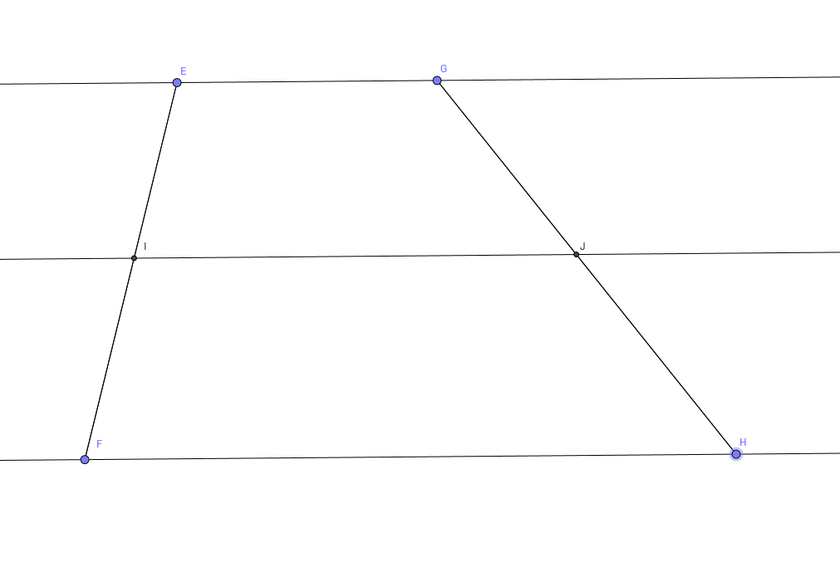

Construct three parallel lines.
Construct segments between the parallel lines as shown in the picture.
Explore the ratios between pairs of segments.

Inscribed Angles and Central Angles

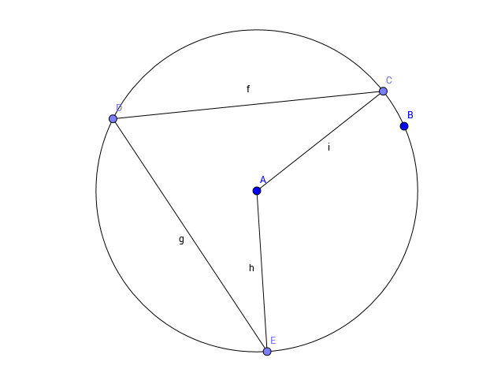

Create a construction similar to the one shown above and use the angle measure tool to investigate central and inscribed angles.
Note: When you select the points that define the angle, do it in the way you name angles, selecting the vertex as the middle point.
If you get a reflex angle click on the button on the right side of the screen that looks like and angle and change the option to 0-180.
