Hexagon Task possible solution paths
Tops and bottoms plus ends. In this strategy, the student considers the tops of the hexagons as two times the train number and the bottoms. Since there are two sides on top of each hexagon, the number of top sides on any train is n x 2 (n hexagons x 2 top sides per hexagon) or 2n. Similarly, the number of bottom sides is also 2n Then, the two end sides are considered separately.
Possible representations: Verbal description. Equations: 2n + 2n + 2 or 2(2n) + 2.

2(2 sides)
3(2 sides)
1(2 sides)

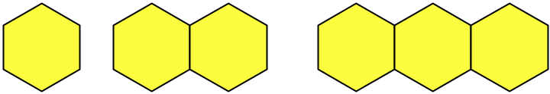
2 ends
2 ends
2 ends
2(2 sides)
3(2 sides)
1(2 sides)

Tops and bottoms of each plus ends. In this strategy, the student considers the tops of each hexagon and the bottoms of each hexagon. Then, the two end sides are considered separately.
Possible representations: Verbal description. Equations: 4n + 2, or (2 + 2)n + 2

4 sides + 4 sides + 4 sides
4 sides + 4 sides
4 sides (top and bottom)
2 ends
2 ends
2 ends

Insides and Outsides. In this strategy, the student considers the end hexagons, noticing that each contributes five to the perimeter. Then, they consider that each internal hexagon contributes four.
Possible representations: Verbal description. Equations: 5 + 4(n – 2) + 5, or 4(n – 2) + 5 + 5 , or 4(n – 2) + 10.

The second train is the two end hexagons that will be separated. They have 5 sides each (not including the one shared in the middle). Thus, the perimeter is 5+5 or 10.
The hexagon is the middle being added. This adds two on top and two on the bottom for 4 sides total. For every added hexagon, 4 more sides needs to be added to the second train whose perimeter is 10.

Note: the formula does work on Train 1, even though one can’t really see the 5 and 5 in the train.
Total minus shared sides. In this strategy, the student considers that each hexagon has six sides and notices that sides between hexagons are no longer on the perimeter.
Possible representations: Verbal description. Equations: 6n – 2(n – 1)

3(6 sides) - 4
3(6 sides) – 2 (n-1)
2(6 sides) - 2
2(6 sides) – 2(n-1)
1(6 sides)

Symmetry split. In this strategy, the student considers the top sides and one end side as a unit and the bottom sides with the other end side.
Possible representations: Verbal description. Equations: (2n + 1) + (2n + 1) or 2(2n + 1)

This time its 3 plus 2 plus 2 on the top…times two, because it’s also on the bottom.

(2n+1) + (2n+1) if you think top and bottom
2(2n+1) if you think doubling
There is two sides on the top of each, plus an end…and the same on the bottom
There are 3 sides above (two sides and one end) and it repeats below it.

Increases by four. In this strategy, the student notices that the perimeter values increase by four with each additional hexagon.
Possible representations: Verbal description.
Equations: 4n + 2.
Table: list values., notice an increase of 4 each time (may conclude equation is n + 4, which is correct if n is the perimeter of the n-1th train)
Graph: plot points.
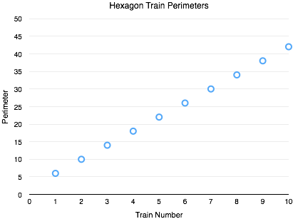
Plotted the points for each of the trains after counting the perimeter of each, and realized the pattern was linear, increasing by four as the train number increases by one as the slope.

y = mx + b
y = 4x + b (used a point and guess and check to solve for b)

y = 4x + 2
[or could connect all the points on graph w/ a straight edge and see that when x=0, y=2]

