Hexagon Task

Trains 1, 2, 3 and 4 (shown below) are the first 4 trains in the hexagon pattern. The first train in this pattern consists of one regular hexagon. For each subsequent train, one additional hexagon is added.

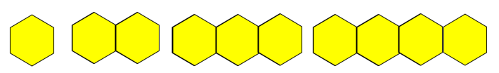
Train 1 Train 2 Train 3 Train 4

- Compute the perimeter for each of the first four trains.
- Draw the fifth train and compute the perimeter of the train.
- Determine the perimeter of the 10th train without constructing it.
- Write a description that could be used to compute the perimeter of any train in the pattern.
- Determine which train has a perimeter of 110.

This task was adapted from Visual Mathematics Course 1, Lessons 16-30 published by the Math Learning Center. Copyright © 1995 by The Math Learning Center, Salem, Oregon.

