Main Toolbar Keys in Geometer’s Sketchpad
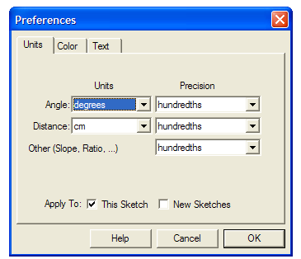
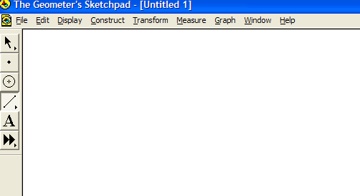
Text Tool used to label points and segments.
Straightedge Tool. Click and hold, drag to choose Segment Tool, Ray Tool or Line Tool. Release when over the tool you want to use. Then click to start segment/ray/line, drag for length, then release.
Custom Tool – Not Needed Now
Compass Tool for creating a circle. Click on Compass Tool. Then click and drag to make circle.
Point Tool for creating a point. Click on the point tool, then click on the space you want the point to be.
Selection Arrow Tool for choosing objects (points, lines, figures, etc.) Deselect by clicking on blank space.

Click on Edit Menu and drop down to select Preferences. This window will pop up. Make sure your information looks like this. Choose “degrees” for Angle and “cm” for Distance and have Precision set for hundredths. Then click on OK in the bottom right.

