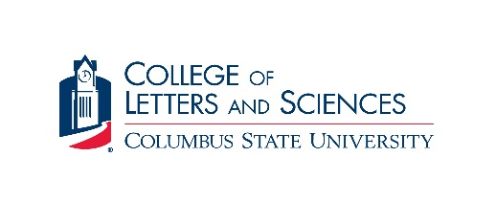

Biology Alumni Scholarship Application

Eligibility:
- Full-time student (sophomore or higher status) pursuing a degree in biology at CSU
- GPA of 2.5 or higher
- Exhibit a financial need, based on information provided on FAFSA

Awards: Up to $1,000 (fall semester); awardees may re-apply each year

Instructions:
- Complete this application.
- Complete the Free Application for Federal Student Aid (FAFSA) for the appropriate academic year listing Columbus State University (school code 001561). The Columbus State University Financial Aid Office must receive the results of the FAFSA by the scholarship deadline (June 29).
- Include a typed statement (approximately 250 words) describing how the scholarship would help you complete your degree.
- Attach your unofficial CSU transcript.
- Include a copy of your resume or CV.
- Submit the application materials, in person or by email, by 5pm on June 29 to:
Ely Klar (Klar_Elizabeth@ColumbusState.edu)
Department of Biology (Jordan Hall 333)
4225 University Ave.
Columbus, GA 31907-5645

- Select applicants may be interviewed by a selection committee where they will be asked to discuss their interest in biology and their career or graduate school plans.

PLEASE PRINT OR TYPE INFORMATION
1. Full Name:
2. Street Address: City: State: Zip:
3. CSU I.D. Number: Date of Birth:
4. State of Residence: County of Residence:
5. Telephone Number: (Home) (Work)
6. Email Address:
7. Major: Grade Level: GPA:
8. Have you applied for any other form of financial aid, including student loans? Yes No
If yes, list sources and amounts:

Signature Date

